

Кафедра вычислительной техники

Программирование

**Лабораторная работа №3**

**Вариант** **96**

Преподаватель: Елена Блохина

Выполнил: Вали Насибулла

Р3132

Санкт-Петербург

2020

1. **Task:**

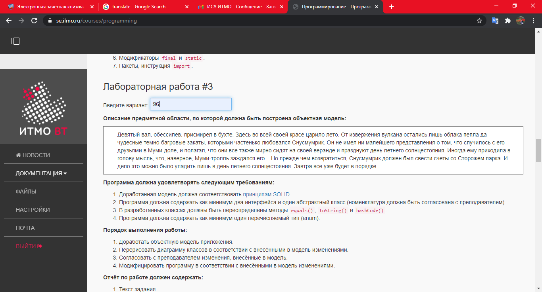

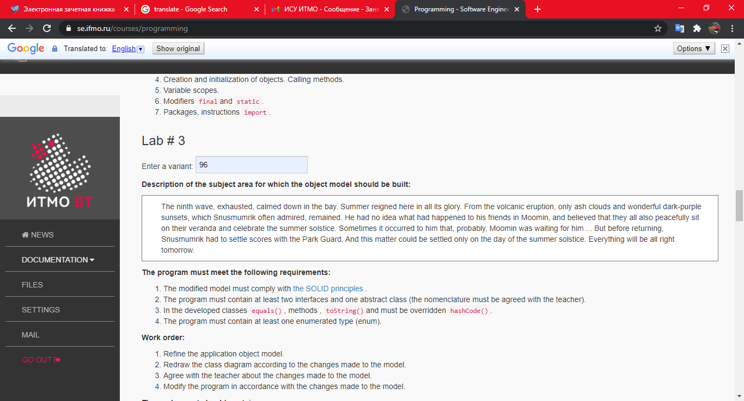

1. **Diagram:**

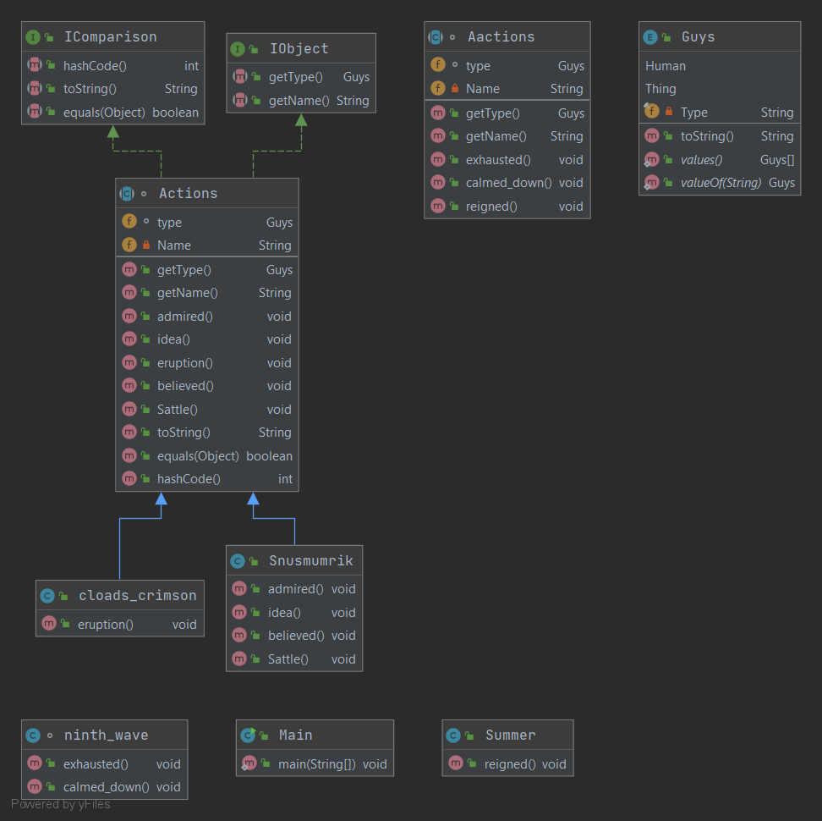

1. **Codes:**
2. Action

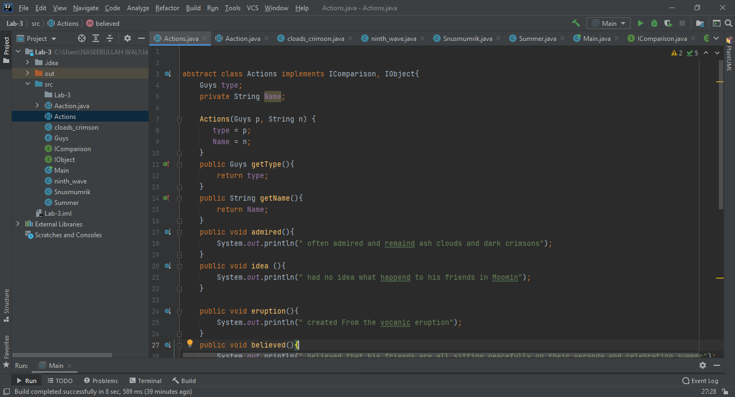

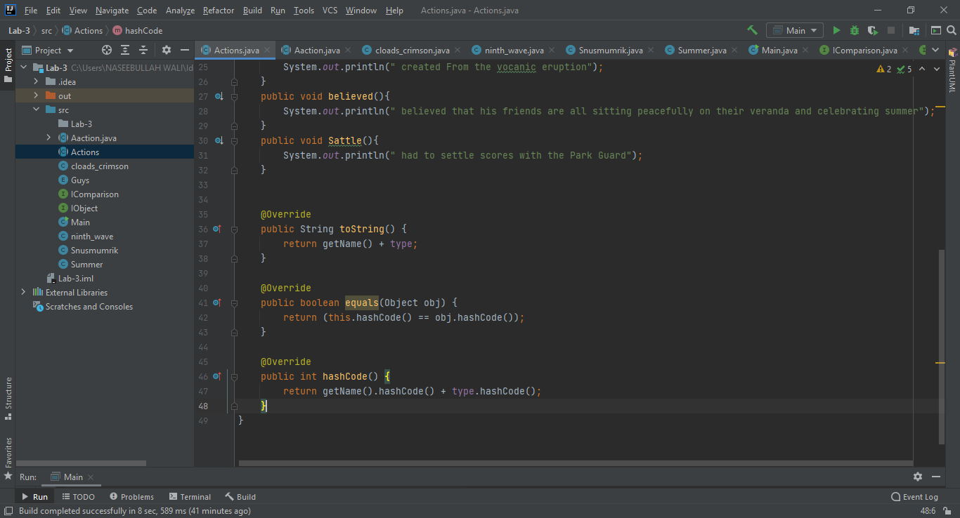

1. 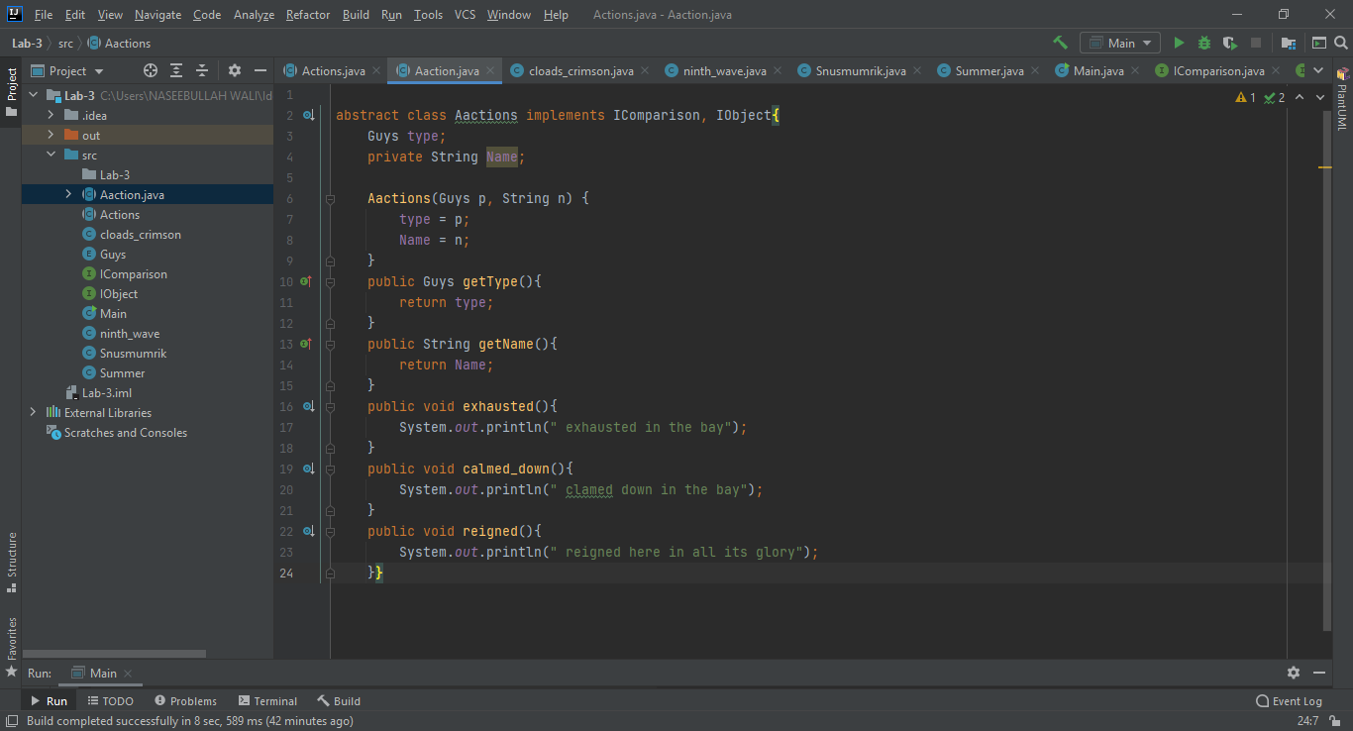Aaction:
2. Guys:

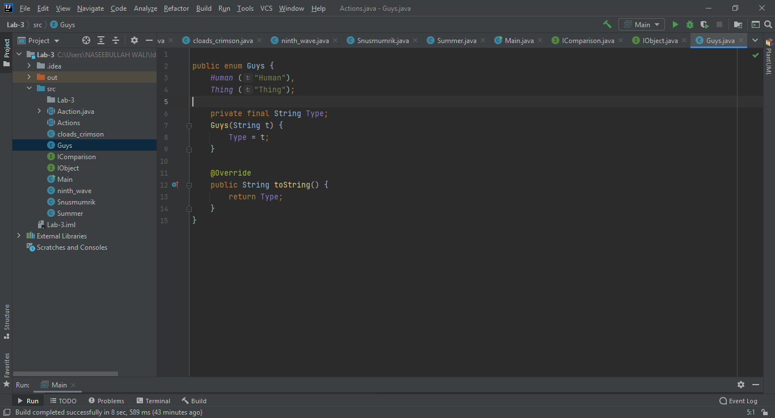

1. 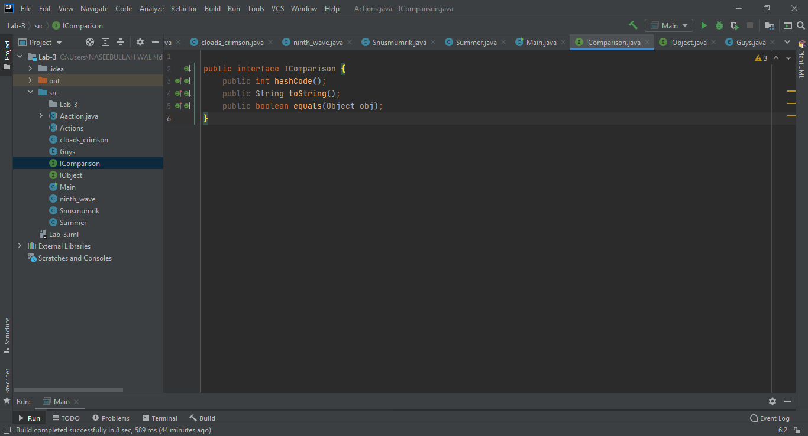Icompare
2. Iobject:

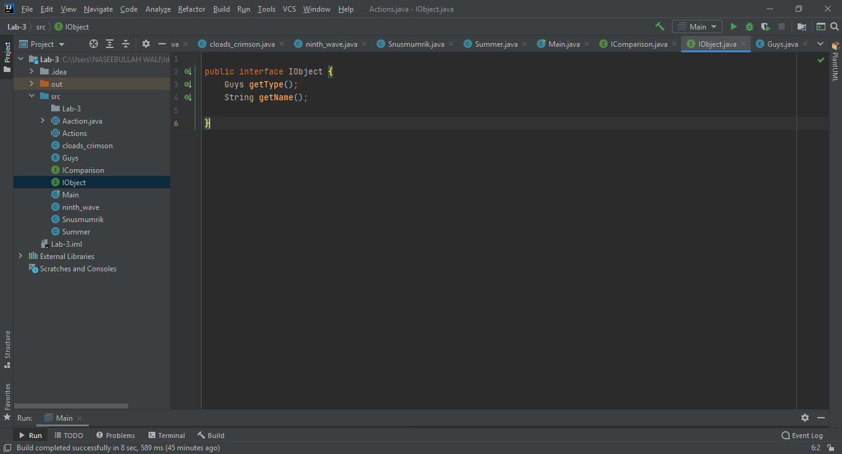

1. 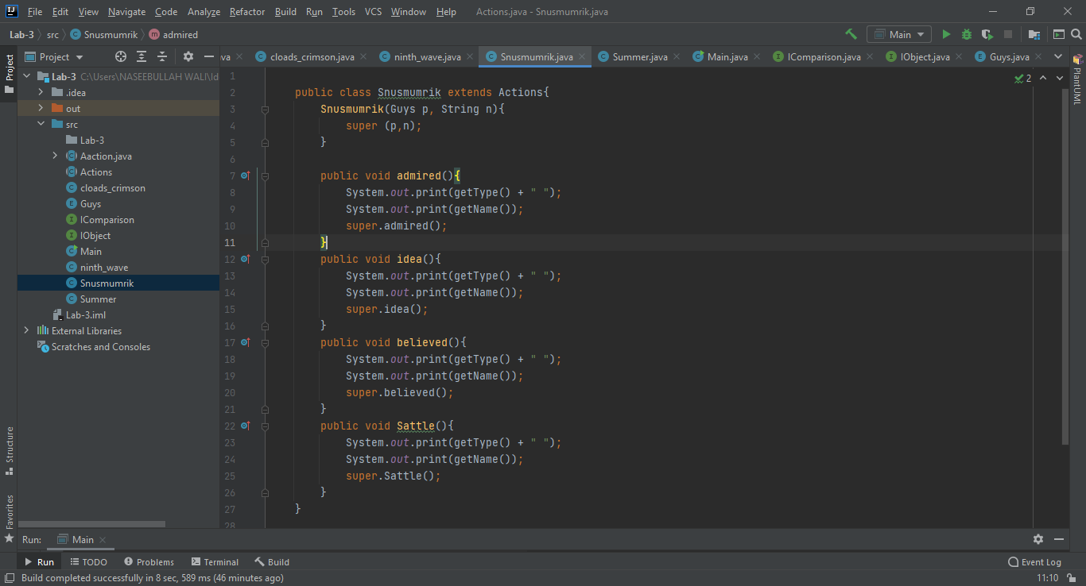Nameperson:
2. 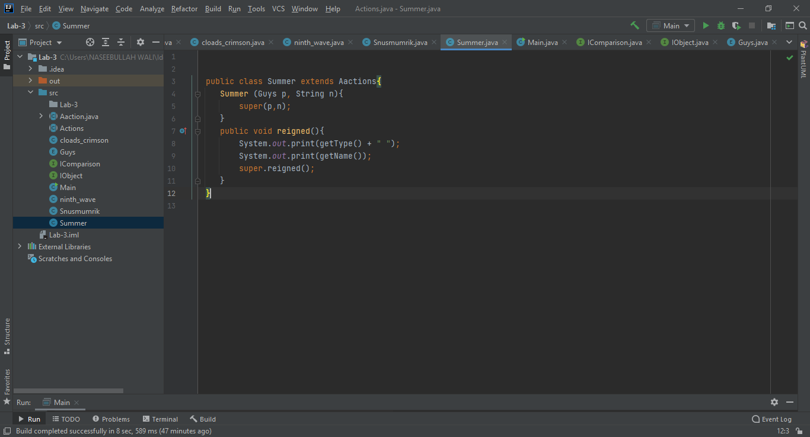Summer:
3. 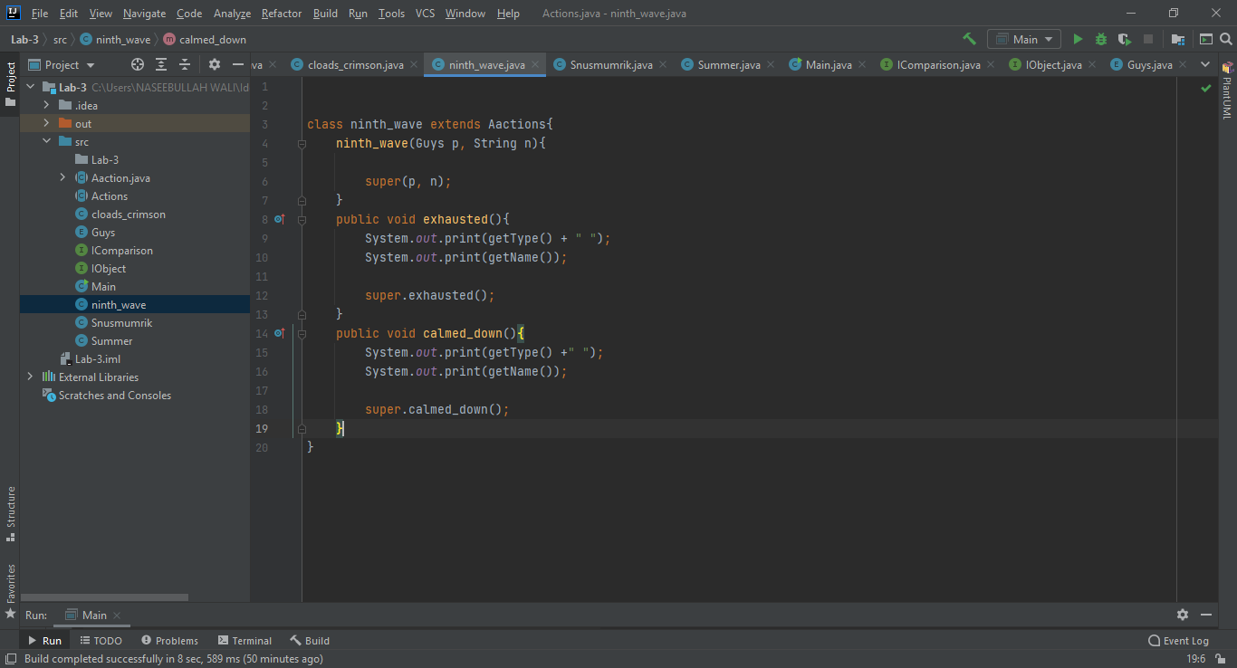 ninth_wave:
4. 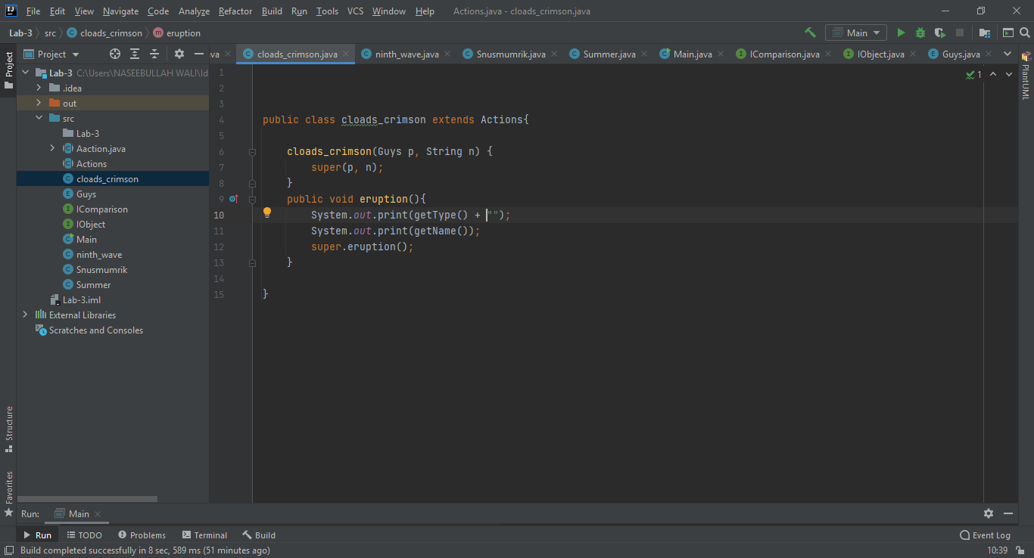Clouds_crimson:
5. Main:

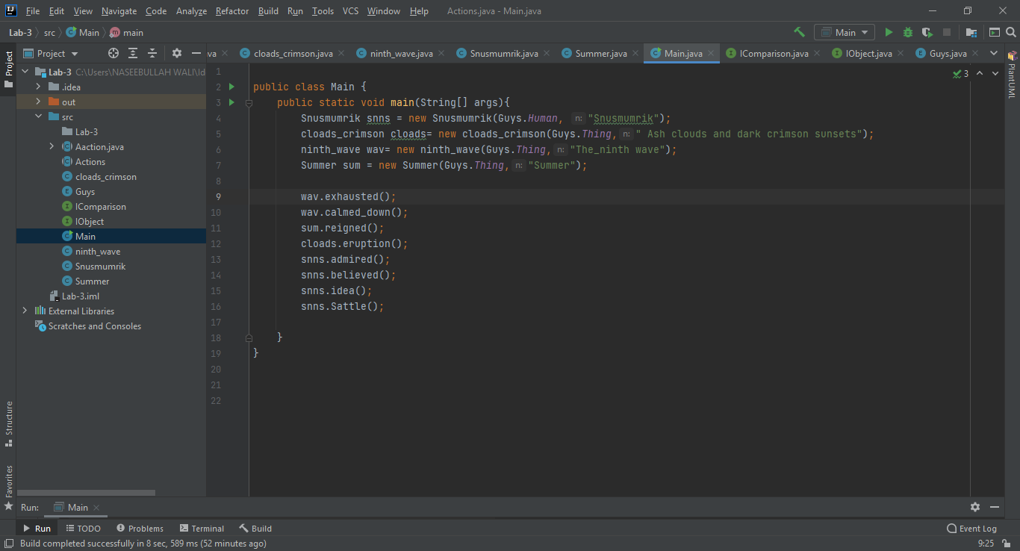

**Results:**

Thing The_ninth wave exhausted in the bay

Thing The_ninth wave clamed down in the bay

Thing Summer reigned here in all its glory

Thing Ash clouds and dark crimson sunsets created From the vocanic eruption

Human Snusmumrik often admired and remaind ash clouds and dark crimsons

Human Snusmumrik believed that his friends are all sitting peacefully on their veranda and celebrating summer

Human Snusmumrik had no idea what happend to his friends in Moomin

Human Snusmumrik had to settle scores with the Park Guard

**Conclusion:**

After finishing this lab I in rich my knowledge in oop programming in java. Plus I also learn some new concepts.